**# The Davis Difference Goes Global**

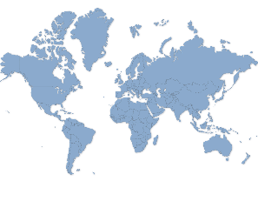**MCj01160860000[1]**



Our 8th annual “**MAKE KINDNESS COOL”** celebration will be observed during the first 2 full weeks in February. The goal of this event is to foster a culture of respect, kindness and acceptance of differences. During this time, the staff will emphasize the importance of being kind to each other and to those who are in need that may live close by or far away. We are encouraging and discussing respect for others and random acts of kindness during classroom counseling lessons.

This is the second year we are sponsoring a service project for a very worthwhile charity called Edu-Pack. Edu-Pack gives away school supplies to children in developing countries like Haiti, Honduras, Jamaica and here in the U.S. There are an estimated 130 million children of primary school age who are not in school because their parents cannot afford basic school supplies. Edu-Pack is trying to change that one backpack at a time. We are asking each grade level to donate specific items to fill these backpacks as listed below. If you would like for your child to participate, please send in the item listed below for the grade level of your child. Due to need and import/customs guidelines, we are asking for the following specific items.

**Kindergarten – Pencil Sharpeners (small manual type)**

**1st Grade - Erasers (large white, pink or pencil top type)**

**2nd Grade - #2 pencils**

**3rd Grade – Rulers - 6” metric and US 12” standard**

**4th Grade - Blue and/or black pens**

**5th Grade Pencil Pouches- (Gender neutral pouch *NOT plastic boxes)**

We will have 2 theme days each week as described below:

**TUESDAY, 2/5 – “Think of Kindness.” Wear your favorite cool hat.**

**THURSDAY, 2/7- “Team Up DAVIS, Respect Each Other.” Wear DAVIS spirit wear.**

**TUESDAY, 2/12 –“Be Kind to Animals Day” Wear animal prints or animal clothing.**

**THURSDAY, 2/14 –“Kindness Makes Your Heart Glow”.** **Wear neon colors or heart colors like red, purple and pink.**

***~Participation in the theme days and school supply project is much appreciated.~***

**Contact one of the counselors, Mrs. Plomaritis or Ms. Bernier if you have any questions.**

**LET’S FILL SOME BACKPACKS!**